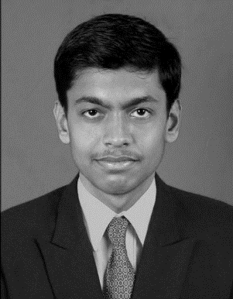**CURRICULAM VITAE**

Dharmesh A. Kholiya

Mob: +918866410833

Email: dharmesh_kholiya@yahoo.com

Career Objective:

“To perform with positive attitude and to work in a dynamic organisation where I can utilize my full potential, skills and knowledge and commitment to achieve organisational goals in profitable way.”

Educational Qualification:

|  |  |  |  |
| --- | --- | --- | --- |
| ***Degree*** | ***Year of Passing*** | ***Institute/Board/Uni.*** | ***Percentage (%)*** |
| MBA (Finance-Running) | 2015 (Potential) | DBIM, VNSGU, Surat | 8.37/10  (for 1st year) |
| BBA (Finance) | 2013 | NLCCM, VNSGU, Navsari | 73.58 % |
| H.S.C. (XII) | 2010 | GSHSEB | 76.57 % |
| S.S.C. (X) | 2008 | GSHSEB | 67.85 % |

**Project work:**

An Independent project entitled as ***“*Creating an optimal portfolio with Sharpe model on Sensex scrip’s*”*** had been undertaken in BBA 6th sem. under the guidance of Ms. Hetal Tandel, Assistant Professor of NLCCM, Navsari. The project was undertaken for the partial fulfillment of getting BBA Degree.

**Achievement:**

* Secured Topper’s position at graduation level.

**Industrial training:**

* Underwent a Summer Training Programme at Flexpro Electricals Pvt Ltd, GIDC, Navsari, Gujarat in BBA after the 4th sem.
* 8 weeks of Summer Training-cum-Internship Programme at Marwadi Shares and Financial Pvt Ltd in MBA after the 2nd sem.

**Technical proficiency:**

* Technically Proficient in MS Word, MS Excel and MS PowerPoint and also proficient with Tally and Internet.

**Extra-Curricular Activities:**

* Attended Industrial Visit to Mafatlal Denim Co. Ltd., Navsari in B.B.A.
* Attended industrial visit to Adani port, kutch in M.B.A.
* Attended Workshop of Dr. Aditya Shrinivas - Chief operating officer & chief economist of BSE on “**Global Financial crisis**”.
* Take a part in **invincibles** at DBIM as a volunteer in Rangmanch game.

**Special skills:**

* Hard working
* Punctuality
* Sincere
* Innovative
* Learning Spirit

**Hobby’s:**

Playing Cricket, Chess and puzzle games etc. Internet Surfing, Travelling, etc.

**Language Known:**

English, Hindi, Gujarati

**Personal Detail:**

**Name :** Dharmesh A. Kholiya

**Father’s Name :** Arvindbhai K. Kholiya

**Mother’s Name :** Meenaben A. Kholiya

**Date of Birth :** 26th Jun, 1993

**Gender :** Male

**Address :** Shayamnagar-4, b/h Nandanvan, Vijalpore road,

Navsari, Gujarat, India.

**Nationality :** Indian

**Linguistic Proficiency :** English, Hindi, Gujarati (Speak, Read and Write)

**Mobile :** +91 8866410833

**E-mail ID :** dharmesh_kholiya@yahoo.com

**I hereby affirm that the above information is true to the best of my knowledge.**

**PLACE:**

**Date: *Dharmesh Kholiya***

========================xxxxxx=======xxxxxx=========================